**Appendix D: Curriculum Vitae**

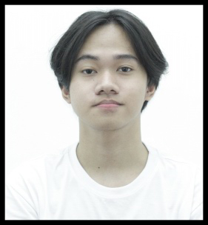

**DAMIAN, MILES DAVID M.**

Nilasin 1st, Pura, Tarlac

+639182698011

darcmephisto@gmail.com

**OBJECTIVE**:

As an aspiring IT professional specializing in Web and Mobile Applications, I aim to leverage my skills in programming, software development, and problem-solving to contribute to innovative projects. I am eager to apply my knowledge of web and mobile technologies in a dynamic environment and continuously grow as a developer.

**PERSONAL DATA**

Birthday: February 27, 2000

Age: 24 years old

Height: 5’4 ft

Weight: 67 kg

**EDUCATIONAL ATTAINMENT**

**SECONDARY EDUCATION:**

* **JUNIOR HIGH SCHOOL**

Pura Central High School

JJCV+FQP, Pura, Tarlac

         S.Y. 2013-2016

* **SENIOR HIGH SCHOOL**

         STI Tarlac

FHPP+CFH, Ninoy Aquino Blvd, San Vicente, Tarlac City, Tarlac City, 2300

S.Y. 2016-2018

**TERTIARY EDUCATION:**

         Tarlac State University, San Isidro Campus, College of Computer Studies

         TSU San Isidro Campus, 2300 Tarlac

Bachelor of Science in Information Technology Specialized in Web and Mobile Application

S.Y. 2021-2025